How to add one user to multiple groups in one shot using power shell:

CODE:

$User = <username>

$Groups = @("group1","group2","..."groupN")

ForEach ($Group in $Groups) {Add-ADPrincipalGroupMembership $User -MemberOf $Group}

WITH SYNTAX:

$User = “john.doe@example.com”

$Groups = @("Managers","System Access")

ForEach ($Group in $Groups) {Add-ADPrincipalGroupMembership $User -MemberOf $Group}

SYNTAX IMAGE EXAMPLE:

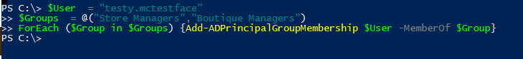

distinguishedName attribute for test account:

CN=mctestface testy,OU=Store Managers,OU=Fran Users,DC=francescas,DC=local